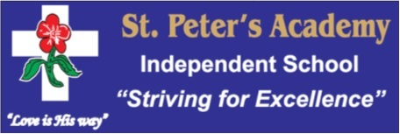

ST PETER’S ACADEMY

SCHOOL RULES

All the children of St Peter’s Academy have good manners – We: -

- Walk / Never Run - only walk in the passages and quad.
- Are never loud mouthed - never use bad language, swear, scream or back chat. If we do not have something good to say we rather say nothing.
- Respect one another - we keep our hands off other learners. Boys show respect to girls and girls acknowledge this.
- Never fight - we do not have bullies in our school. We never play dangerous games and look out for each other.
- Have good manners - Greet teachers. Stand back and allow an adult to go first. Greet visitors with - Good morning Sir/Ma’am. Ask permission to use bathroom. We do not walk around in class. Knock on a door before entering.
- Respect school property - keep hands and feet off the walls. Do not damage trees, flowers and plants. Do not write or scratch on desks or furniture.
- Respect for books - Take extra care of our school and library books. Keep our books packed neatly and our desks tidy and don’t write in text or library books.
- Do not litter - we use a dirt bin for rubbish and re-cycle where we can. Do not throw objects over the walls.
- Eat healthy - do not bring sweets or junk food to school. Do not chew bubble or chewing gum.
- Dress neatly – We take pride in our uniform and keep ourselves clean, neat and tidy. We keep our hair tidy and our nails short and clean. We look after our clothes.
- Do not bring Personal Property - No cell phones, no toys, no valuables to school. We can use the school phone if necessary. If I bring one I will hand it in to the office until home time.
- No loitering – in the toilets, hallways or outside classrooms.
- Are Punctual - we are on time for school. If late we report to the office. We never “bunk” school.
- Are proud - we are always proud of ourselves, our school and were we come from.

